Ideation Phase
Empathize & Discover

Date | 30 September 2026
Team ID | SWTID-2026-9545
Project Name | Import Data using Transform Maps (Spreadsheet) – ServiceNow
Maximum Marks | 4 Marks

Empathy Map Canvas:
An empathy map is a simple, easy-to-digest visual that captures knowledge about a user’s behaviours and attitudes. It helps the team understand the user’s goals and challenges before designing a solution.
Target user: A ServiceNow administrator / HR data coordinator who receives bulk employee data as an Excel sheet and must load it into ServiceNow accurately, without duplicates.
Empathy Map – Employee Data Import:
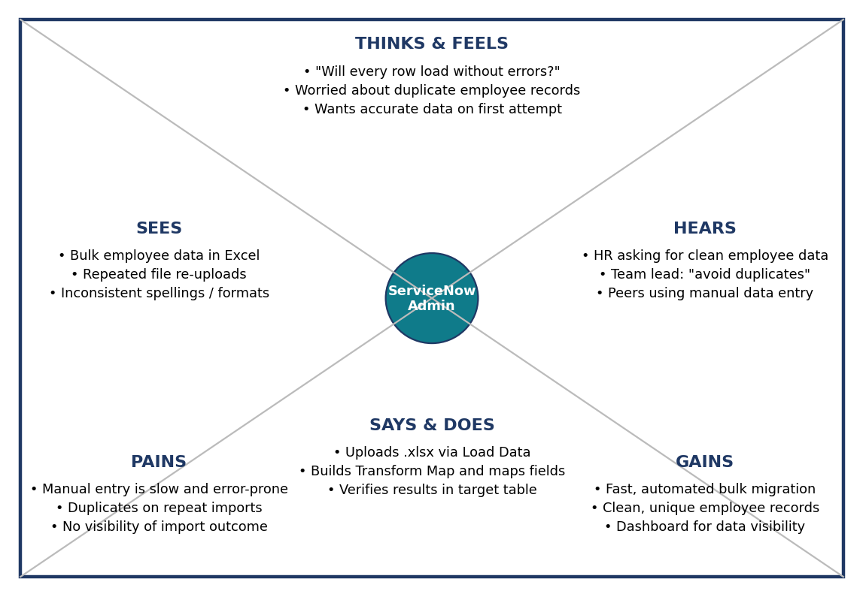
Figure 1: Empathy map for the ServiceNow employee data import scenario
Summary:
Quadrant | Key observations
Think & Feel | Fear of failed or partial loads; anxiety about duplicate employee records; wants confidence that data is correct.
See | Employee data arriving in Excel; the same file being uploaded repeatedly; spelling and format inconsistencies.
Hear | HR asking for clean data quickly; team leads asking to avoid duplicates.
Say & Do | Uploads the file with Load Data, maps fields in a Transform Map, and verifies records in the target table.
Pains | Manual entry is slow; repeated imports create duplicates; no easy view of what was inserted or updated.
Gains | Automated bulk import, unique records via coalesce, and a dashboard showing employee distribution.

Reference: https://www.mural.co/templates/empathy-map-canvas

